SLVGS Scorekeeping Clinic

Home Team is official score keeper for that game and is the person to answer the umpire’s questions – you should sit or position yourself near the backstop or Umpire. Also, the Home Team will be responsible for reporting final game scores to Division Rep. at the end of the game (via email or text).

Visiting team will keep score for their team coach in his/her book.

Be Prepared:
- Always bring at least 2 pencils with erasers.
- 15 minutes before game time - get your team’s lineup to have the scorebook filled out and ready to go at game time.
Preparing the Book:
- Write the names of the girls and their numbers in the left column
  - Lineup cards should have players first and last name and jersey number (no nicknames).
- Write the opposing team on one side of the book and your team on the other side along with umpire name and start time (the umpire will let you know start time).
- What you should know:
  - In SLVGS we “bat the line-up” (meaning every girl bats in order) so there is no need to track substitutions.
  - In rec. we don’t keep full scorebooks (i.e. errors, flex, DP’s etc.). We only require a much simpler form of scorekeeping. You only need keep track of pitches (balls and strikes), hits, runs, who is up, total score, who pitched during inning, last out.
    - If your coach wants more detailed scorekeeping they can give you additional instruction.
    - Hard copy scorekeeping is required so that if a parent on a team wants to keep score on something electronic like an ipad, there will have to be an additional parent keeping score in a regular book.

Scorekeeping Instructions – at the game:

1B | Single | The hitter is safe on first base without any errors occurring in the field | 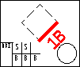
2B | Double | The hitter is safe on second base without any errors occurring in the field | 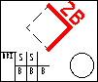
3B | Triple | The hitter is safe on third base without any errors occurring in the field | 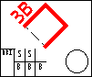
HR | Home Run | The hitter hits the ball over the outfield fence, or safely touches all four bases without an error in the field | 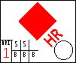
RBI | Run Batted In |  | Indicated by numeral in RBI box see above illustration
BB | Base on Balls and/or Walk |  | 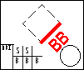
HBP | Hit by Pitch |  | 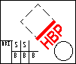
SB | Stolen Base |  | 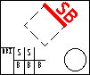
Many scorers use two different symbols for Strike outs. The reason for this is to distinguish between a strike out swinging or a strike out watching (called third strike). Most coaches like to know this information.
K | Strike Out  Swinging  K - KS |  | 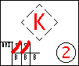
KW | Strike Out  Watching  KW or Backwards K | KW or a backwards K can be used to denote the batter didn't swing but rather was called out watching the third strike. | 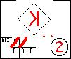

Here are the numbers associated with each position which can be used when marking how the out takes place (in rec. we play 10 players….the position names are left and right center/old school was buck short) That extra player must start on the grass:

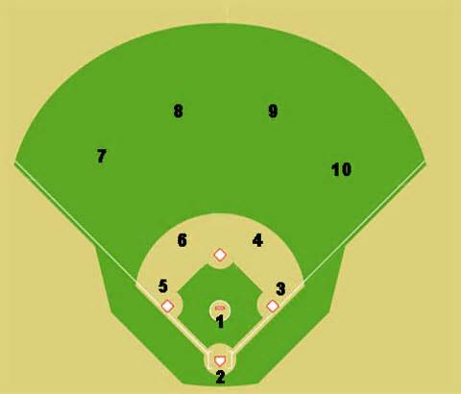

There are two schools of thought on marking where the ball goes. I use the player positions to mark where it goes. In other words if the ball was hit to left field, I would note 7 or 7-3 if an out was made.

An arrow can also be drawn to show where the ball went.

In the box above I know that the batter hit the ball to first base (1) and it was caught by the first baseman (u) unassisted. I also know it was the first out of the game.

Finally, game score totals are tallied in different ways depending on which book you are using…I like the checkbook method…I note the score for that inning and then I accumulate the total score for the game as I go.

